SUPERMARKET SALES
Data Analysis Project

Comprehensive Statistical & Visual Analysis
Dataset: 1,000 Transactions | 3 Cities | 6 Product Lines | 2019
Attribute | Details
Source File | supermarket_sales_project_2.csv
Total Records | 1,000 sales transactions
Branches & Cities | 3 branches — Yangon, Naypyitaw, Mandalay
Product Lines | 6 categories of retail products
Date Range | January 2019 – March 2019
Key Variables | Unit Price, Quantity, Gross Income, Rating, Payment Method

Question 1: How Many Items Were Sold in a Year?
This question counts the total number of items (units) sold across all transactions, all branches, and all product lines in 2019. Each row in the dataset represents one invoice, and the Quantity column tells us how many units were purchased in that transaction.

Year | Total Items Sold | Total Transactions | Average Qty per Transaction
2019 | 5,510 | 1,000 | 5.51 units

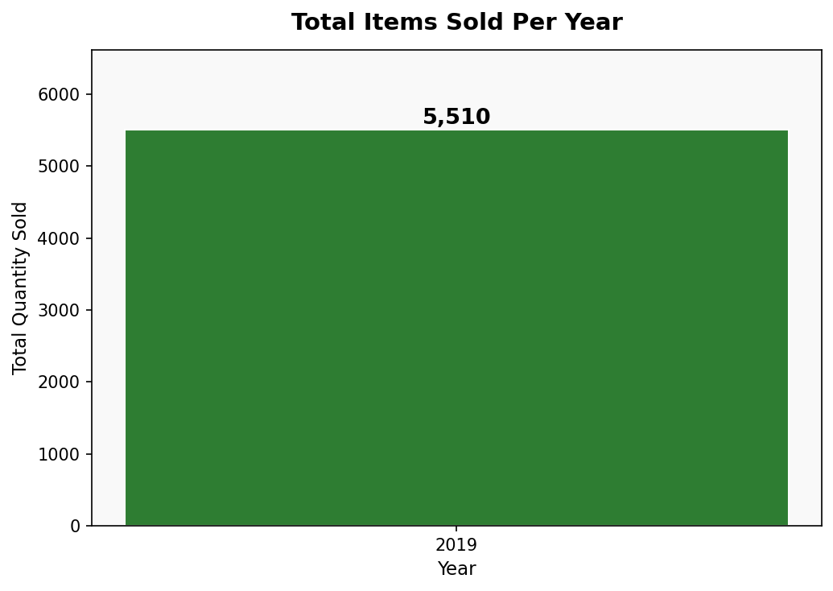
Key Finding
A total of 5,510 units were sold across 1,000 transactions in 2019. This gives an average of 5.51 items per invoice. Since the dataset covers only January to March 2019, these represent Q1 transactions. The chart confirms all sales belong to the year 2019.

Question 2: Which Product Line Has Maximum Quantity Sold in Every City?
We grouped the data by City and Product Line, then summed the Quantity for each combination. For each city, we identified which product line had the highest total units sold. This helps understand city-wise customer preferences and demand patterns.

City | Top Product Line | Quantity Sold
Yangon | Home and Lifestyle | 371
Naypyitaw | Food and Beverages | 369
Mandalay | Sports and Travel | 322

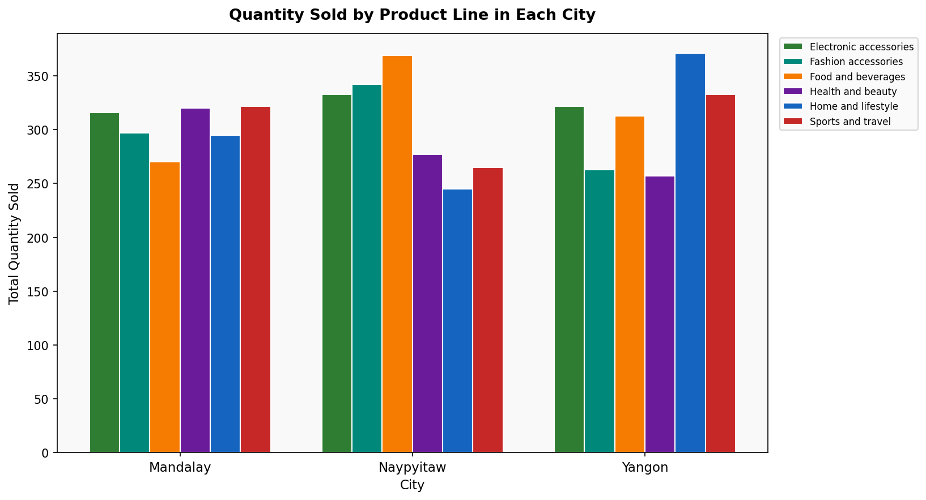
Key Finding
Each city has a different top-selling product line: Yangon leads with Home and Lifestyle (371 units), Naypyitaw with Food and Beverages (369 units), and Mandalay with Sports and Travel (322 units). This shows that customer preferences vary by location, which is important for city-specific stocking and marketing decisions.

Question 3: Which Product Line Has Minimum Quantity Sold in a Year?
To find the least popular product line, we totalled all units sold per product line across the entire year. The product line with the lowest total quantity indicates where customer demand is weakest and may require attention in terms of promotions or restocking strategy.

Rank | Product Line | Total Quantity Sold
1 (MINIMUM) | Health and Beauty | 854
2 | Fashion Accessories | 902
3 | Home and Lifestyle | 911
4 | Sports and Travel | 920
5 | Food and Beverages | 952
6 (MAXIMUM) | Electronic Accessories | 971

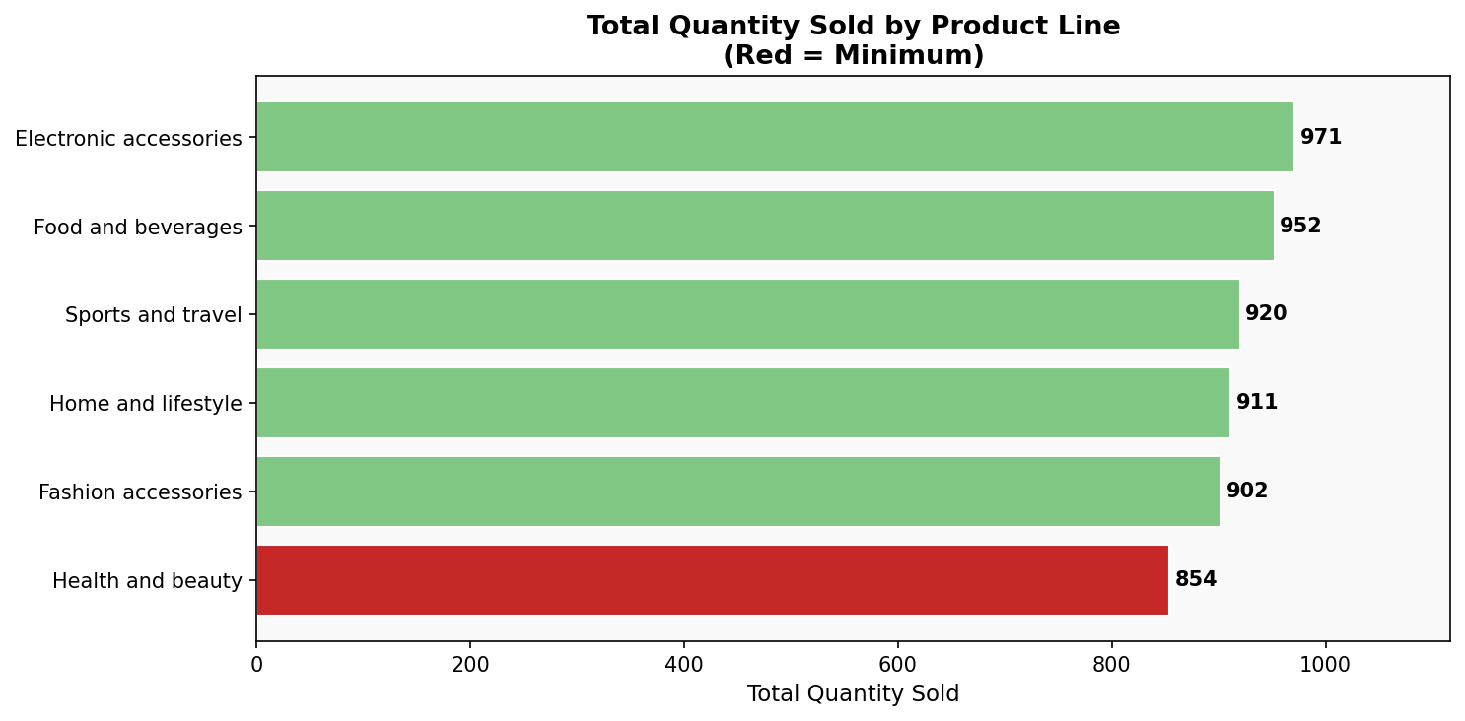
Key Finding
Health and Beauty has the minimum quantity sold with 854 units — about 12% less than the top-performing Electronic Accessories (971 units). The overall range across product lines is relatively narrow (854 to 971), suggesting fairly balanced demand. However, Health and Beauty may benefit from targeted promotions to close this gap.

Question 4: Correlation Between Unit Price and Quantity
The Pearson Correlation Coefficient (r) measures the linear relationship between two numeric variables. It ranges from -1 to +1. A value near +1 means both increase together; near -1 means one increases as the other decreases; near 0 means no linear relationship exists between the variables.

Metric | Value
Pearson Correlation Coefficient (r) | 0.0108
Interpretation | Negligible / No meaningful linear relationship
Mean Unit Price | $55.67
Mean Quantity | 5.51 units
Price Range | $10.08 – $99.96
Relationship Direction | No significant pattern observed

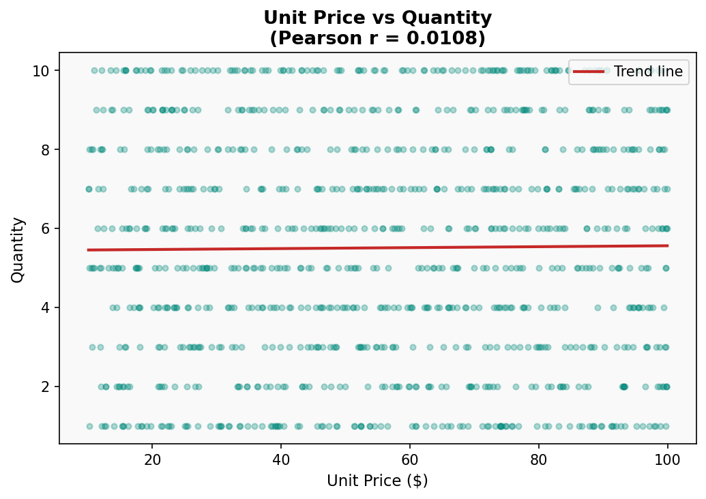
Key Finding
The correlation of 0.0108 is essentially zero — meaning there is no linear relationship between unit price and quantity purchased. Customers at this supermarket buy roughly the same quantity regardless of whether a product is cheap or expensive. This is typical of grocery/supermarket shopping behaviour where necessity drives purchase, not price sensitivity alone.

Question 5: Sales Report for Every Product Line
This section presents a comprehensive sales performance report for each of the 6 product lines. The report covers total revenue, total quantity sold, number of transactions, average unit price, average customer rating, and average gross income per sale — giving a 360-degree view of each product category.

Product Line | Total Revenue | Total Qty | Transactions | Avg Unit Price | Avg Rating | Avg Gross Income
Food & Beverages | $56,144.84 | 952 | 174 | $56.01 | 7.11 | $15.37
Sports & Travel | $55,122.83 | 920 | 166 | $56.99 | 6.92 | $15.81
Electronic Accessories | $54,337.53 | 971 | 170 | $53.55 | 6.92 | $15.22
Fashion Accessories | $54,305.90 | 902 | 178 | $57.15 | 7.03 | $14.53
Home & Lifestyle | $53,861.91 | 911 | 160 | $55.32 | 6.84 | $16.03
Health & Beauty | $49,193.74 | 854 | 152 | $54.85 | 7.00 | $15.41

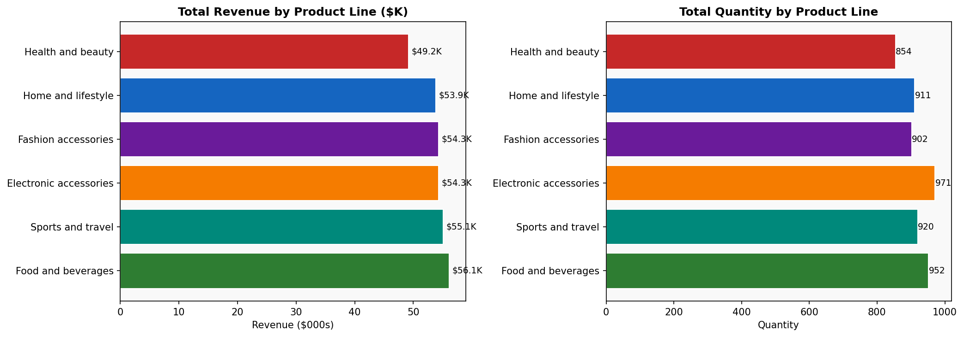
Key Finding
Food and Beverages leads in total revenue ($56,144) and also has the highest average customer rating (7.11). Health and Beauty is the weakest performer across both revenue ($49,193) and transaction count (152). Home and Lifestyle earns the highest average gross income per sale ($16.03), making it the most profitable per transaction despite not being the top revenue earner.

Question 6: Standard Deviation of Quantity and Unit Price
Standard Deviation (σ) measures how spread out values are from the mean (average). A low σ means values cluster tightly around the mean; a high σ means values are widely scattered. It helps us understand consistency and variability in sales data.

Metric | Quantity | Unit Price
Mean (Average) | 5.51 units | $55.67
Standard Deviation (σ) | 2.9234 | $26.4946
Minimum Value | 1 unit | $10.08
Maximum Value | 10 units | $99.96
Coefficient of Variation | 53.1% | 47.6%
Interpretation | Moderate spread — customers buy 1–10 items | Wide spread — products range from cheap to expensive

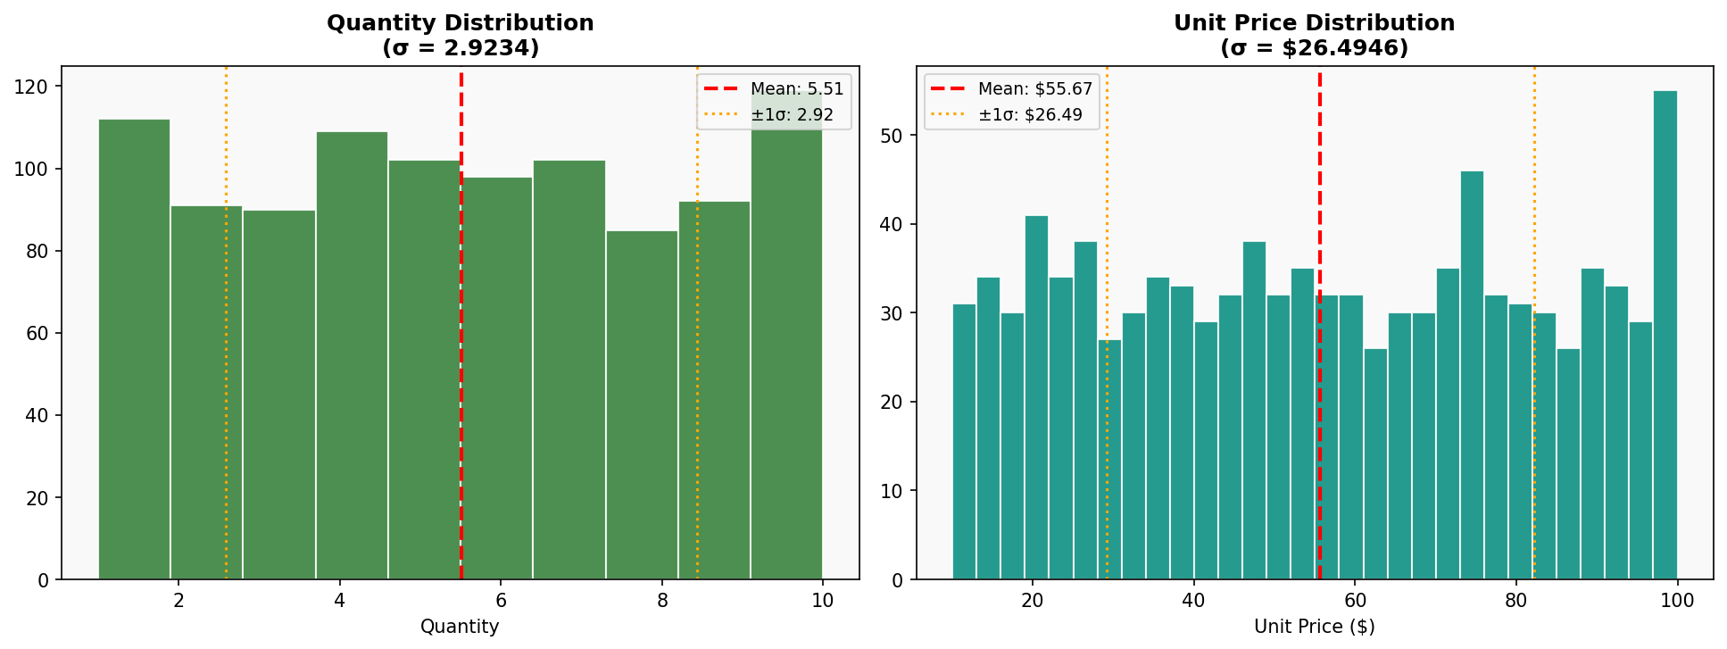
Explanation — What does this mean?
Quantity σ = 2.92: On average, purchase quantities deviate by ~3 units from the mean of 5.51. So most customers buy between 3 and 9 items. The histogram shows a fairly uniform distribution across quantities 1–10 — customers are equally likely to buy any amount. Unit Price σ = $26.49: Prices deviate widely from the mean of $55.67. This tells us the product catalogue spans a broad price range — from budget items (~$10) to premium products (~$100). The histogram shows a relatively flat, wide distribution, confirming prices are spread evenly rather than clustered around one point.

Question 7: Relationship Between Quantity and Unit Price
This explores whether the price of a product influences how many units a customer purchases in one transaction. Economic theory (Law of Demand) suggests that higher prices should lead to lower quantities. We test this hypothesis using correlation analysis.

Metric | Value
Pearson Correlation Coefficient (r) | 0.0108
Interpretation | No meaningful relationship
Expected (Economic Theory) | Negative — higher price → lower quantity
Actual Finding | Near-zero — price does not drive quantity here
Possible Reason | Supermarket shoppers buy based on need, not price alone

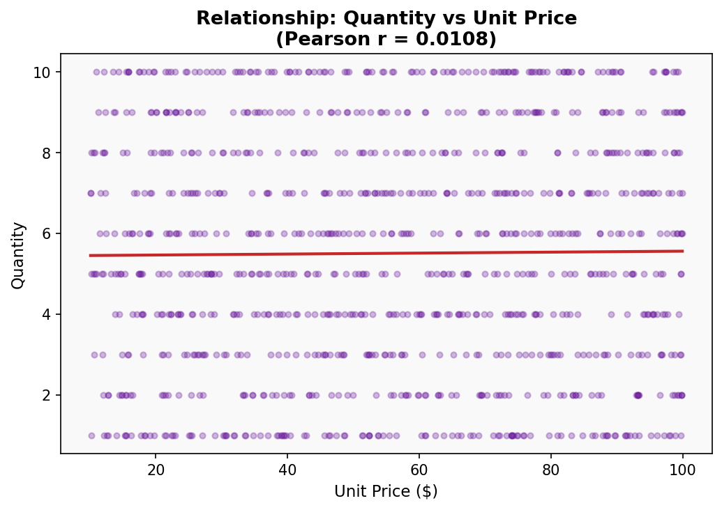
Explanation
The scatter plot shows a completely random cloud of points with no visible upward or downward slope — confirming r = 0.0108. There is virtually no linear relationship between unit price and quantity. This means customers at this supermarket do not buy more of cheaper products or fewer of expensive ones in any consistent pattern. This could be because supermarket purchases are largely need-driven (grocery shopping) and customers pre-plan their shopping list regardless of price.

Question 8: Relationship Between Rating and Gross Income
This question examines whether customers who spend more (higher gross income per transaction) tend to give higher ratings. One might expect that a positive shopping experience (e.g., finding what you need, spending more) would translate to higher satisfaction scores.

Metric | Value
Pearson Correlation Coefficient (r) | -0.0364
Interpretation | Negligible Negative — no meaningful relationship
Mean Rating | 6.97 out of 10
Mean Gross Income | $15.38 per transaction
Finding | Spending amount does not predict customer satisfaction

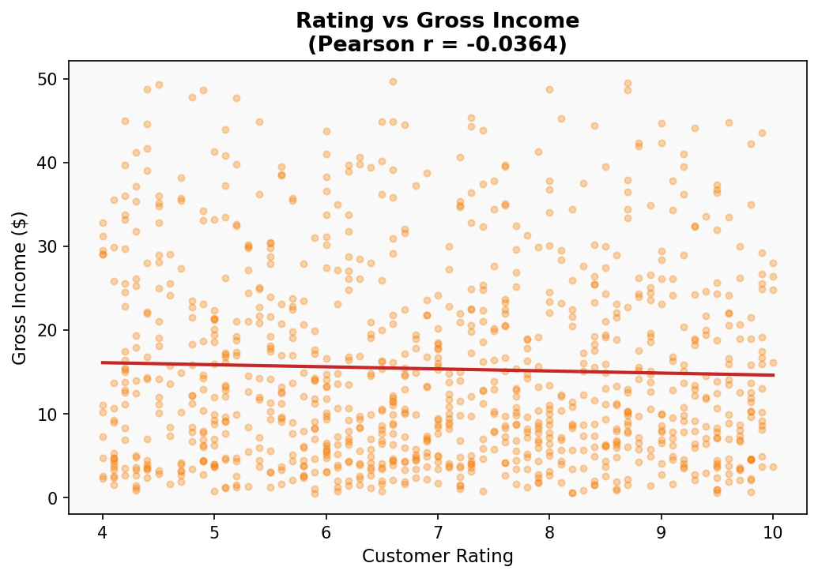
Explanation
The correlation of -0.0364 is essentially zero, showing no meaningful relationship between how much a customer spends and the rating they give. High spenders are not necessarily more satisfied, and low spenders are not necessarily less satisfied. This suggests customer satisfaction at this supermarket is driven by service quality, product availability, or shopping experience — not by the transaction value. For management, this means investing in service quality improvements is more likely to improve ratings than simply increasing average order values.

Question 9: Relationship Between Rating and Quantity
This explores whether customers who buy more items in one visit tend to rate their experience differently. One hypothesis might be that larger basket sizes indicate a more satisfying shopping trip (found everything needed), resulting in a higher rating.

Metric | Value
Pearson Correlation Coefficient (r) | -0.0158
Interpretation | Negligible — no relationship between quantity and rating
Mean Quantity | 5.51 units per transaction
Mean Rating | 6.97 out of 10
Finding | Number of items purchased does not affect customer satisfaction

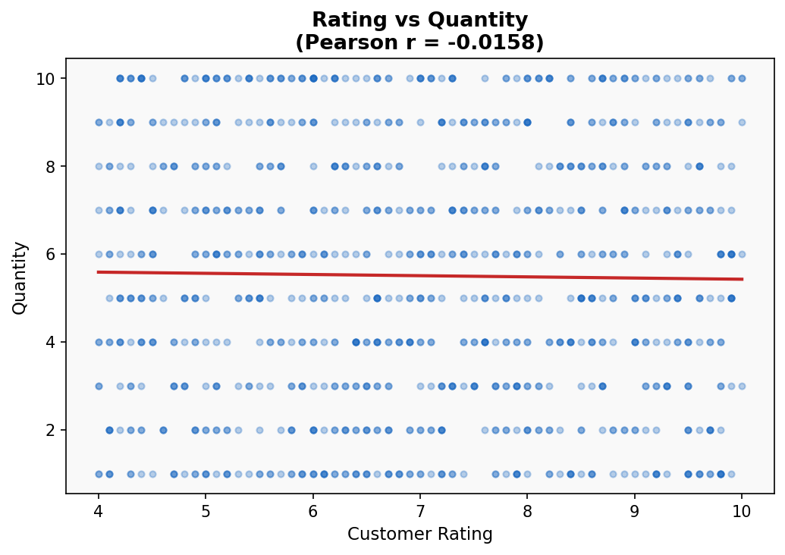
Explanation
The correlation of -0.0158 confirms there is no meaningful relationship between how many items a customer buys and the rating they give. Whether a customer buys 1 item or 10 items, their satisfaction score is equally likely to be high or low. This reinforces the finding from Q8 — ratings at this supermarket appear to be independent of transactional factors like spend amount and basket size. Instead, factors like staff behaviour, queue time, product quality, and store ambiance likely have a much stronger influence on satisfaction.

Question 10: Comprehensive Analytics Dashboard
The dashboard below consolidates all key analytical views of the Supermarket Sales dataset into a single unified visual. It allows decision-makers to quickly assess sales performance, product line comparisons, customer behaviour patterns, pricing distributions, and satisfaction trends at a glance.

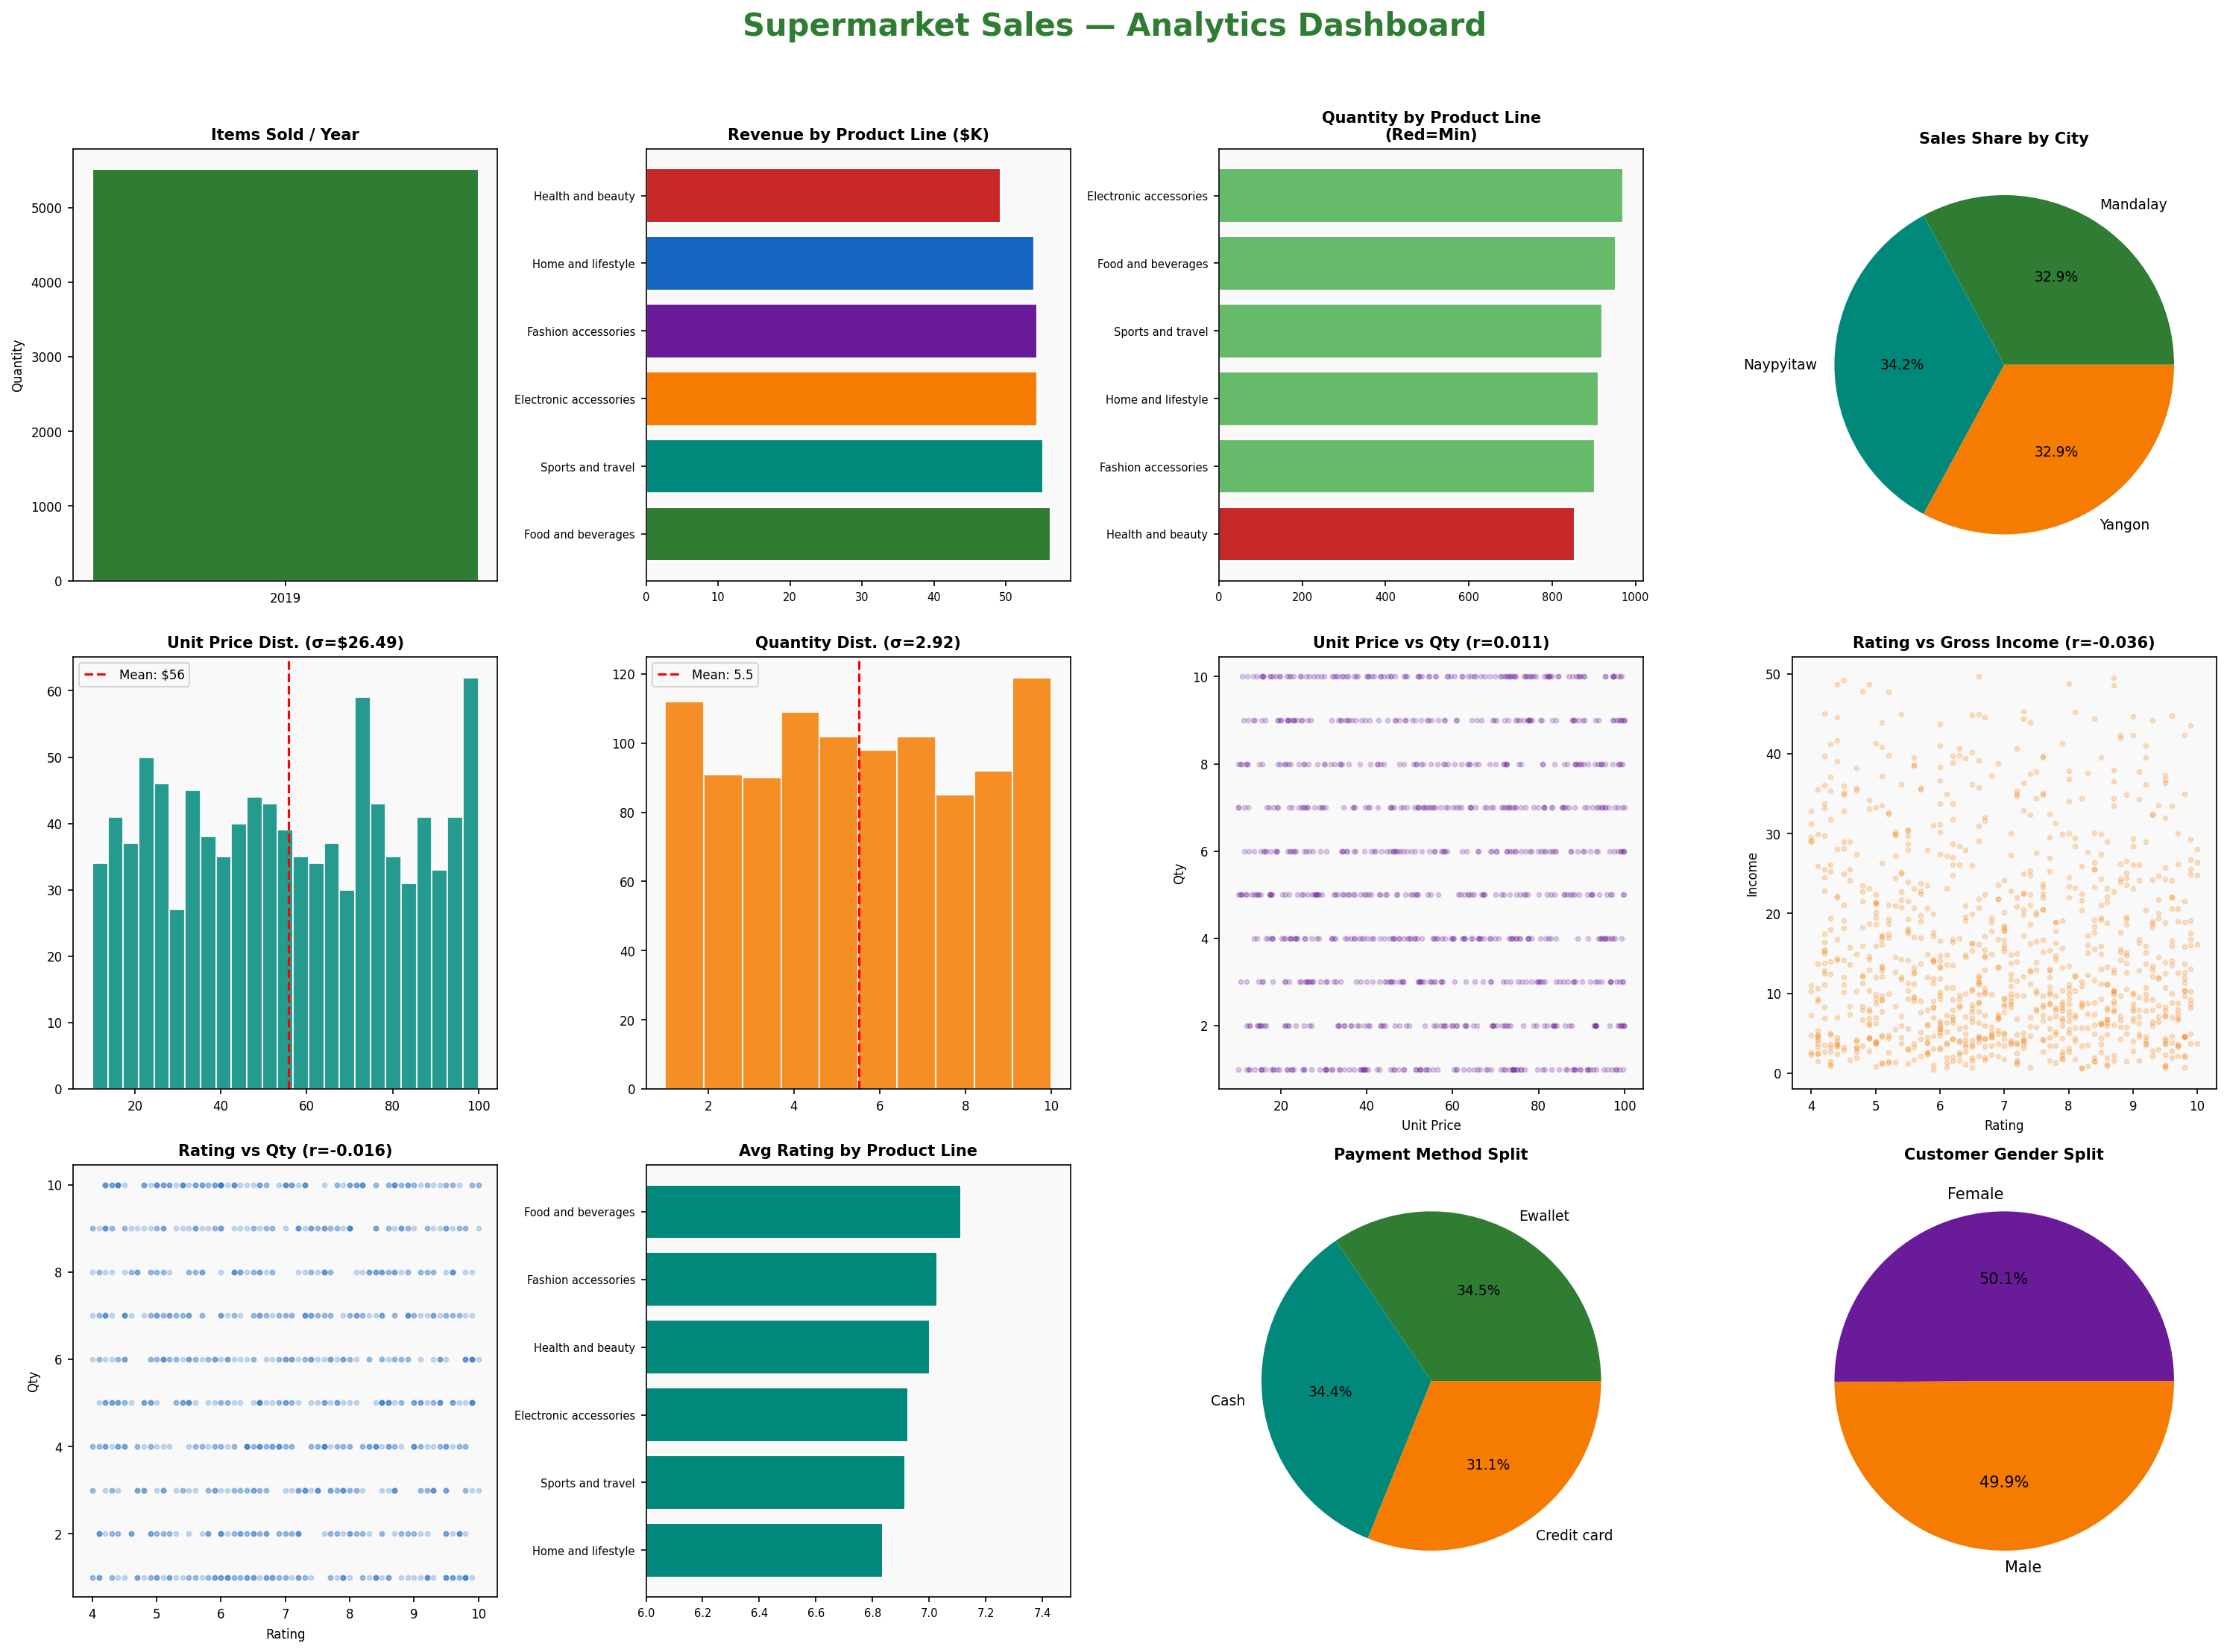
Dashboard Components:
- Items Sold Per Year — total quantity across all transactions
- Revenue by Product Line — Food & Beverages leads at $56K
- Quantity by Product Line — Health & Beauty lowest (highlighted in red)
- Sales Share by City — near-equal split across Yangon, Naypyitaw, Mandalay
- Unit Price Distribution — wide spread (σ = $26.49)
- Quantity Distribution — uniform spread from 1–10 units
- Unit Price vs Quantity — near-zero correlation (r = 0.011)
- Rating vs Gross Income — no relationship (r = -0.036)
- Rating vs Quantity — no relationship (r = -0.016)
- Average Rating by Product Line — Food & Beverages rated highest
- Payment Method Split — nearly even between Cash, Ewallet, Credit Card
- Customer Gender Split — near-equal Male/Female customer base

Summary & Conclusions
This project analyzed 1,000 supermarket sales transactions across 3 cities and 6 product lines from January to March 2019. The following table summarizes all 10 findings:

Question | Key Finding
Items Sold Per Year | 5,510 total units across 1,000 transactions (avg 5.51 per invoice)
Max Qty by City | Yangon: Home & Lifestyle | Naypyitaw: Food & Beverages | Mandalay: Sports & Travel
Min Qty Product Line | Health and Beauty (854 units) — lowest demand across all product lines
Unit Price vs Qty Correlation | r = 0.011 — No relationship; customers buy irrespective of price
Sales Report | Food & Beverages = top revenue ($56K); Health & Beauty = lowest ($49K)
Standard Deviation | Qty: σ = 2.92 (moderate spread) | Unit Price: σ = $26.49 (wide spread)
Qty vs Unit Price Relationship | r = 0.011 — No meaningful relationship confirmed
Rating vs Gross Income | r = -0.036 — Spending level does not drive customer satisfaction
Rating vs Quantity | r = -0.016 — Basket size has no influence on ratings
Dashboard | All 12 analytical views consolidated in one unified dashboard

Overall, the supermarket demonstrates balanced performance across cities and product lines. No strong correlations were found between pricing, quantity, and customer satisfaction — suggesting that satisfaction is driven by intangible factors such as service quality and store experience rather than purely transactional variables.

